**REPUBLIC OF TÜRKİYE**

**YILDIZ TECHNICAL UNIVERSITY**

**GRADUATE SCHOOL OF SOCIAL SCIENCES**

**.......... DEPARTMENT**

**............................. PROGRAM**

**MASTER'S THESIS / DOCTORAL THESIS / PROFICIENCY IN ARTS**

**THESIS TITLE**

**STUDENT NAME SURNAME**

**STUDENT NUMBER**

**THESIS SUPERVISOR**

**TITLE NAME SURNAME**

**YEAR**

**REPUBLIC OF TÜRKİYE**

**YILDIZ TECHNICAL UNIVERSITY**

**GRADUATE SCHOOL OF SOCIAL SCIENCES**

**.......... DEPARTMENT**

**............................. PROGRAM**

**MASTER'S THESIS / DOCTORAL THESIS / PROFICIENCY IN ARTS**

**THESIS TITLE**

**STUDENT NAME SURNAME**

**STUDENT NUMBER**

**ORCID NO: XXXX-XXXX-XXXX-XXXX**

**THESIS SUPERVISOR**

**TITLE NAME SURNAME**

**MONTH YEAR**

# 

The study titled "[Title of the Thesis]" prepared by [First and Last Name ] has been found successful with [ unanimous / majority vote ] as a result of the defense exam held on **[DD/AA/YYYYYY]** and has been accepted by our jury as a **[MASTER’S / DOCTORATE / PROFICIENCY IN ARTS** ] thesis in the [Related] Program.

**Supervisor Signature**

[Title, First and Last Name] ...........................

**Jury Members Signature**

[Title, First and Last Name] ...........................

[Title, First and Last Name] ...........................

[Title, First and Last Name] ...........................

[Title, First and Last Name] ...........................

[Title, First and Last Name] ...........................

# ÖZET

TEZ BAŞLIĞI

Özet özet özet özet özet özet özet özet özet özet özet özet özet özet özet özet özet özet özet özet özet özet özet özet özet özet özet özet özet özet özet özet özet özet özet özet özet özet özet özet özet özet özet özet özet özet özet özet özet özet özet özet özet özet özet özet özet özet özet özet özet özet özet özet özet özet özet özet özet özet özet. [araştırmanın amacı, yöntem, evren örneklem, uygulamalar vb.]

Özet özet özet özet özet özet özet özet özet özet özet özet özet özet özet özet özet özet özet özet özet özet özet özet özet özet özet özet özet özet özet özet özet özet özet özet özet özet özet özet özet özet özet özet özet özet özet özet özet özet özet özet özet özet özet özet özet özet özet özet özet özet özet özet özet özet özet özet özet özet özet. [genel hatlarıyla araştırmada ulaşılan sonuçlar]

**Anahtar Kelimeler:** Anahtar Kelime 1, Anahtar Kelime 2, Anahtar Kelime 3

# ABSTRACT

TITLE

Summary report summary report summary report summary report summary report summary report summary report summary report summary report summary report summary report summarized summary. Summary report summary report summary report summary report summary report summary report summary report summary report summary report summary report summary report summary report summary report summarized summary [purpose of the research, methodology, population/sampling, applications]

Summary report summary report summary report summary report summary report summary report summary report summary report summary report summary report summary report summary report. Summary report summary report summary report summary report summary report summary report summary report summary report summary report summary report summary report summary report summary report summary report [the results]

**Keywords:** Keyword 1, Keyword 2, Keyword 3, ...

# PREFACE

In this section, the author can provide additional information about the study, that might disrupt the narrative flow if included in the main body of the thesis., This could include both positive and negative situations encountered during the study. In the preface, gratitude is expressed to those who directly contributed to the thesis study and its preparation into a report, as well as to the individuals and institutions who contributed indirectly, even if they did not have an official responsibility. If the thesis was conducted as part of a project, it is essential to include the name of the project and the associated funding organization in the foreword.

Student's Full Name

Month, Year; Istanbul

# TABLE OF CONTENTS

ABSTRACT (in Turkish) iii

ABSTRACT iv

PREFACE v

TABLE OF CONTENTS vi

LIST OF TABLES vii

LIST OF FIGURES viii

LIST OF ABBREVIATIONS ix

1. INTRODUCTION 1

1.1. A Sample Subheading 1

2. USE OF THE TEMPLATE 2

2.1. Regarding Some Problems That May Occur 4

3. FIRST DEGREE HEADING EXAMPLE 5

3.1. Example of a Second Order Heading 5

3.1.1. Example of a Third Degree Heading 5

3.1.1.1.1. Fourth Degree Heading Example 5

4. PRESENTATION OF TABLES AND FIGURES 6

4.1. Spelling of Table / Figure Numbers and Titles 6

4.2. Writing Table / Figure Sources 7

4.3. Automatic Table / Figure Caption Insert via WORD 8

REFERENCES  10

APPENDICES 12

# LIST OF TABLES

Table 1. Second Five-Year Development Plan Public Revenue Targets 7

Table 2. Results According to Academic Achievement Variable 7

# LIST OF FIGURES

**Figure 1.** Inserting Table and Figure Text 7

**Figure 2.**  Classification of Organizational Capabilities 9

# LIST OF ABBREVIATIONS

EU : European Union

IT : Information Technology

SEM : Structural Equation Modeling

PARLIAMENT : Grand National Assembly of Turkey

YTU : YIldIz Technical University

1. INTRODUCTION

TextText text text text text text text text text text text text text text text text text text text text text text text text text text text text text text text text text text text text text text text text text text text text text text text text text text text text text text text text text text text text text text text text text text text text text text text text text text text text text text text text text text text text text text text text text text text text text text text text text text text text text text text text text text text text text text text text text text text text text text text text text text text text text text text text text text text text text text text text text text text text text text text text text text text text text text text text text text text text text text text text text text text text text text text text text text text text text text text text text text text text text text text text text text text text text text text text text

* 1. Sample Subheading

Only first-level headings start on a new page. All subheadings other than first-order headings continue where the text left off. If a subheading falls at the end of a page, it should start on the next page.

No spaces are left with 'Enter' in the thesis text. Use the heading formats specified in the guide.

1. USE OF THE TEMPLATE

*The explanations* to the right of the template indicate the edits you need to make to the template. Do not forget to delete these explanations before the thesis submission. Also, do not forget to delete the explanations made in the following sections with quotations from the Thesis Writing Guide.

In the "Introduction" strip of the template, there are "styles" based on the Thesis Writing Guide

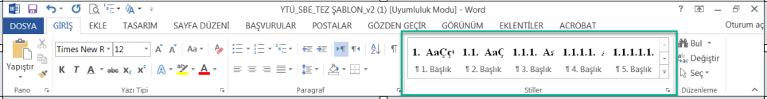

* Heading styles are defined up to level 5. If you use these heading styles, you can create the 'Table of Contents' more easily and automatically.
* The '*Normal*' style is created for standard paragraph writing. It is your and your advisor's choice whether or not to use indentation at the beginning of paragraphs. However, you must apply your preferred method throughout the thesis.
* The '*No Gap'* style is created for the abstract (in Turkish), abstract and preface.
* The '*Table/Figure'* style is created for table/figure captions.
* The '*Direct Citation*' style has been created for direct quotations of 40 words or more (details are available in the thesis writing guide).
* Before you start a new "first order heading", you must add a **"Section Break (Next Page)"** by clicking on the "Page Layout→ Breaks→ Next Page" tabs. If you do not do this, the first order headings will not appear as 72 pt from the top. In this way, you will also comply with the rule "first order headings must start on a new page".

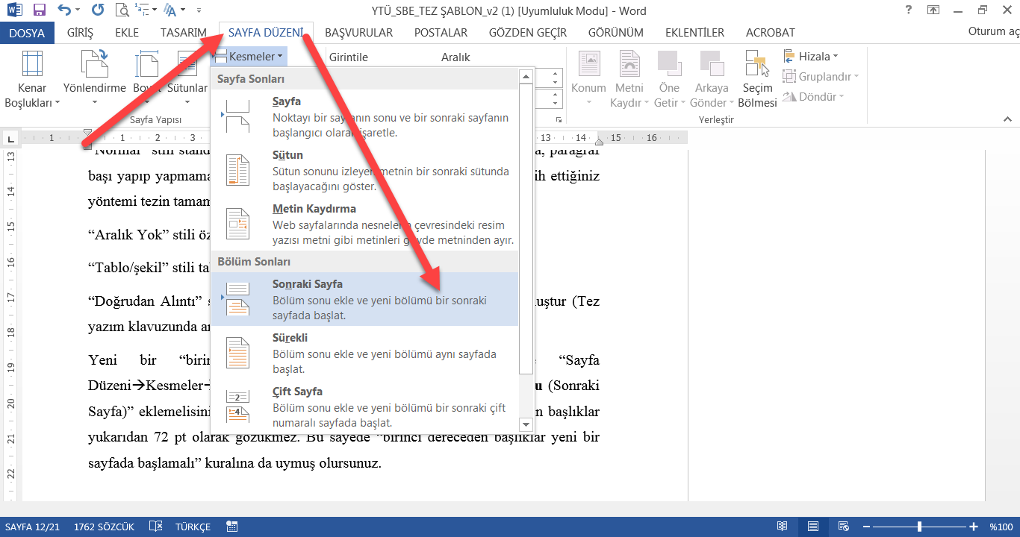

You can turn on the "show all" feature by pressing "ctrl+shift+8" at the same time to see the section breaks you have added to the page. You can disable it by pressing the same keys again. You can enable and disable this feature by clicking on the pointer shown in the image below.

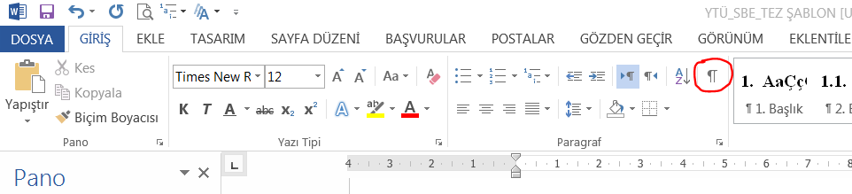

* 1. Regarding Some Possible Problems

**1.** If you see a display like the one below after adding a section break, you need to press the "Enter" key once after the last word.

Wrong;

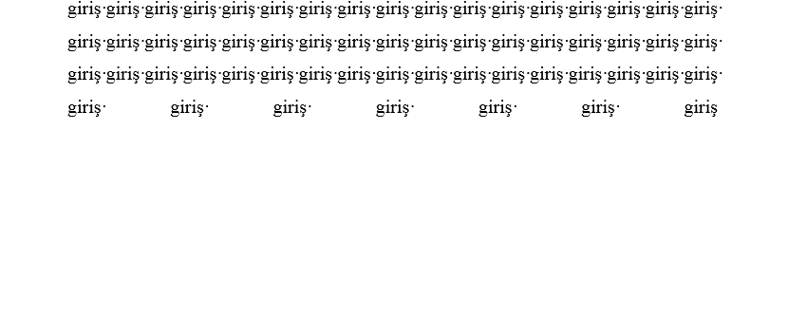

That's right;

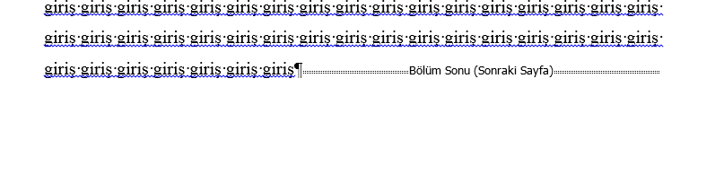

The correct photo above was taken by activating the "show all" feature by pressing ctrl+shift+8 as described earlier. You can disable this feature by pressing the same keys again.

**2.** If page numbers start from 1 when they should not;

double click on the relevant page number→ right click→ format page number→ continue from previous section

Do it.

1. FIRST DEGREE HEADING EXAMPLE
   1. Second Order Heading Example
      1. Third Degree Heading Example
         1. Fourth Degree Heading Example
            1. Fifth Degree Heading Example
2. PRESENTATION OF TABLES AND FIGURES

Tables and figures should be placed as close as possible to the place where they are first mentioned in the text, provided that the principles of page layout are followed. Relevant tables and figures must be referred to in the text.

More than one table or figure may appear on the same page or consecutively. However, no continuous table or figure may be given without providing explanatory information. Multiple tables or figures may be included in appendices when necessary.

* 1. Table / Figure Numbers and Captions

Tables and figures in the thesis, their captions and sources are shown centered on the page. Graphics, maps, pictures, photographs, etc., are all considered as figures.

When creating tables, the page width should not be exceeded. If it cannot be arranged in accordance with the page, the relevant page can be adjusted horizontally; adjustments can be made by reducing the line spacing to a single line or reducing the font size.

Number and caption: Each table and figure has a numbered caption. The captions should be placed above the table and figure. Captions should be **bold, centered, and the first letter of each word** should be **capitalized**.

When numbering tables and figures, one of the following two methods should be preferred:

* Tables and figures are numbered 1, 2, 3... from the beginning of the thesis, regardless of which chapter they are given in
* Tables and figures are numbered as 1.1., 2.3., etc. in each section by first giving the section number and then the table number.

Example;

Table 1. Second Five-Year Development Plan Public Revenue Targets

|  |  |  |  |  |  |  |
| --- | --- | --- | --- | --- | --- | --- |
|  |  |  |  |  |  |  |
|  |  |  |  |  |  |  |
|  |  |  |  |  |  |  |

* 1. Writing Table / Figure Sources

The references of tables and figures **are written below** the relevant **table or figure, centered, 10 pt and italicized.** The in-text citation of the relevant source (the long form of the bibliography will not be written) is given without parentheses, by writing *Source*: and including the page no..

Table Example:

Table 2. Results According to Academic Achievement Variable

|  |  |  |  |  |  |  |  |
| --- | --- | --- | --- | --- | --- | --- | --- |
| **Variable** | **Source of Variance** | **K.T.** | **Sd.** | **K.O.** | **F** | **p** | **Difference** |
| Variable 1 | Between groups | 24,835 | 2 | 12,418 | 8,611 | ,000 | 1-2  2-3 |
| Within groups | 862,389 | 598 | 1,442 |
| Total | 887,225 | 600 |  |

*Source: Sahin, 2004, p. 46*

Figure Example:

Figure 1. Classification of Performance Indicators

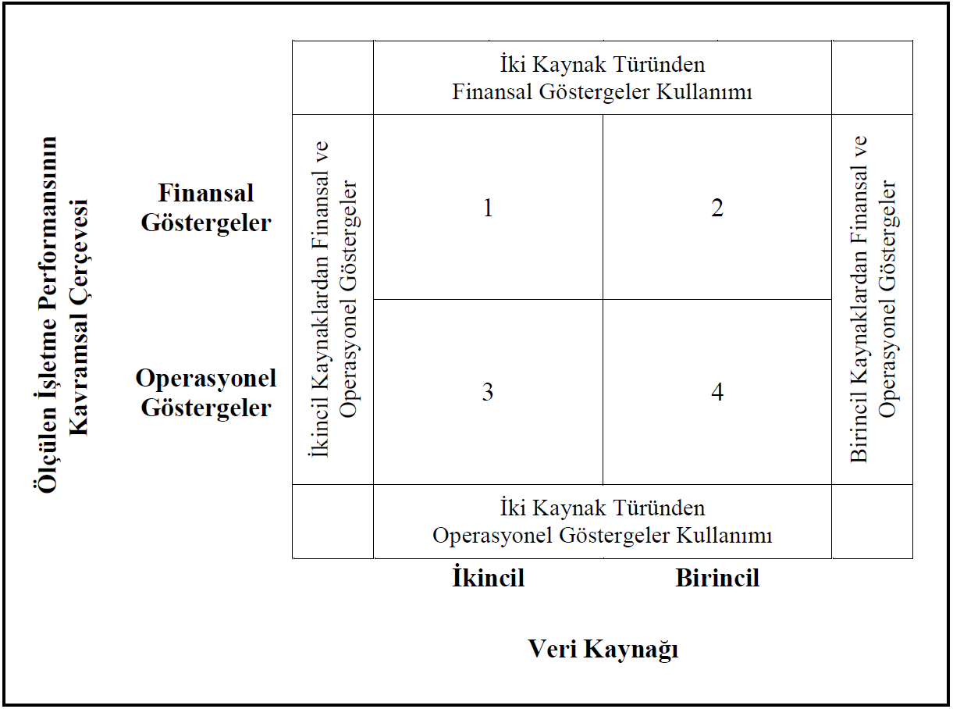

*Source: Venkatraman & Ramanujam, 1986, p.*

* 1. Adding Automatic Table / Figure Captions in WORD

Click on the +-like sign in the upper left corner of the table (see Figure 2), click on the References→ Insert Caption tabs and select "Label: Table". After typing the table name, exit with "OK". Then select the table name and choose the "Table/Figure" style from "Styles".

To add the figure caption automatically, unlike above, just select "Label: Shape". Then similarly select the "Table/Shape" style from "Styles".

Figure 2. Inserting Table and Figure Text

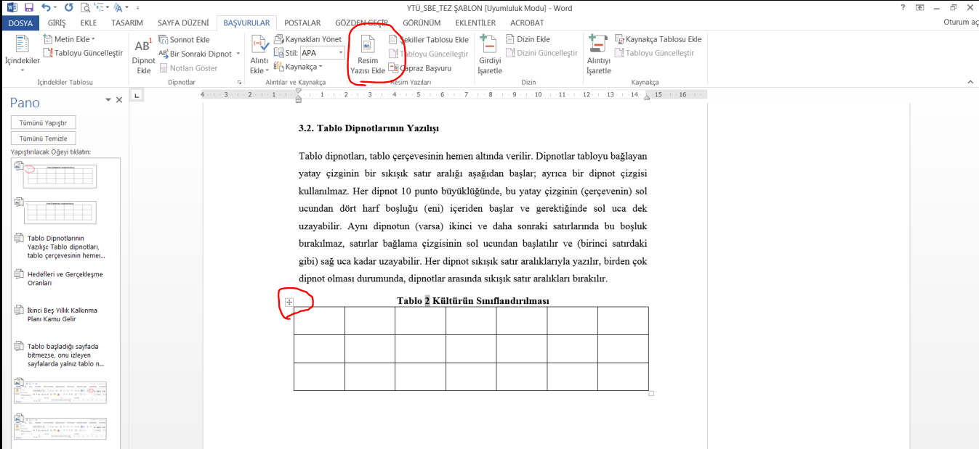

REFERENCES

Follow the American Psychological Association (APA) Publication Manual 7th Edition rules for in-text citations and references. Detailed examples of APA rules can be found in the thesis writing guide. For cases where there is no example in the guide, you can refer to the website [https://apastyle.apa.org/style-grammar-guidelines/references.](https://apastyle.apa.org/style-grammar-guidelines/references)

In accordance with the tradition of the department or upon the recommendation of the supervisor, referencing in the form of 'footnotes' may also be used. Students who choose to write their thesis using this method must first obtain a written approval from the head of the major science/art department stating that the 'footnote' system is applied appropriately. This approval letter must be included in the appendices section of the thesis to be uploaded to the system for thesis template control. This letter requirement applies only to students who choose the footnote citation method (those who use the APA style do no need to submit this).

It is possible to automatically generate a bibliography in Word. You can find detailed information on this topic by searching on the internet.

On Frequently Encountered Problems

If a reference in the bibliography extentds to two or more lines , the second and subsequent lines should be indented by 1 cm, as shown in the example.

*Example:*

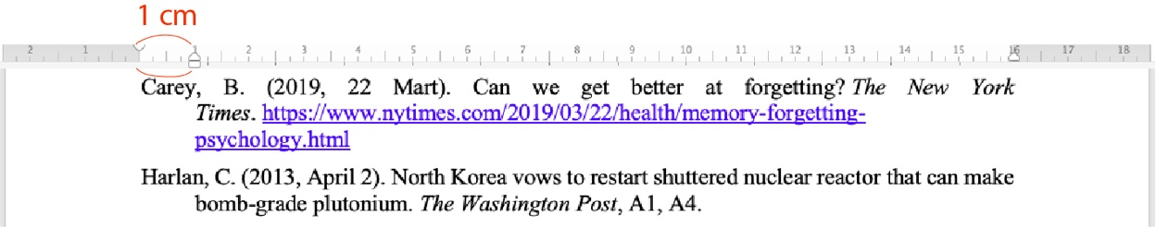

Torino, G. C., Rivera, D. P., Capodilupo, C. M., Nadal, K. L., & Sue, D. W. (2019). *Microaggression theory: Influence and implications*. John Wiley & Sons. <https://doi.org/10.1002/9781119466642>

It is not sufficient nor correct to provide only the name of the website when citing online sources. You can refer to the thesis writing guide for the proper citation format of such sources.

**BIBLIOGRAPHY EXAMPLE**

Baral, P., Larsen, M., & Archer, M. (2019). *Does money grow on trees? Restoration financing in Southeast Asia*. Atlantic Council. <https://www.atlanticcouncil.org/in-depth-research-reports/report/does-money-grow-on-trees-restoring-financing-in-southeast-asia/>

Cacioppo, S. (2019, April 25-28). *Evolutionary theory of social connections: Past, present, and future* [Conference presentation abstract]. Ninety-ninth annual convention of the Western Psychological Association, Pasadena, CA, United States. <https://westernpsych.org/wp-content/uploads/2019/04/WPA-Program-2019-Final-2.pdf>

Çınar, M., Doğan, D., & Seferoğlu, S. S. (2015, February 15). *Digital tools in education: An evaluation on Google classroom application* [Paper presentation]. Anadolu University, Eskisehir. https://ab2015.anadolu.edu.tr/indexphp?menu=5&

Evans, A. C., Jr., Garbarino, J., Bocanegra, E., Kinscherff, R. T., & Márquez-Greene, N. (2019, August 8-11). *Gun violence: An event on the power of community* [Conference presentation]. APA 2019 Convention, Chicago, IL, United States. <https://convention.apa.org/2019-video>

Grady, J. S., Her, M., Moreno, G., Perez, C., & Yelinek, J. (2019). Emotions in storybooks: A comparison of storybooks that represent ethnic and racial groups in the United States. *Psychology of Popular Media Culture*, *8*(3), 207-217. <https://doi.org/10.1037/ppm0000185>

Öztürk, H. Y. (2016). *The mediating role of functional capabilities in the effect of learning orientation on firm performance and the moderating effect of intensity of competition* (Publication No. 454865) [Master's Thesis, Yıldız Technical University]. YÖK National Thesis Center.

Sanchiz, M., Chevalier, A., & Amadieu, F. (2017). How do older and young adults start searching for information? Impact of age, domain knowledge and problem complexity on the different steps of information searching. *Computers in Human Behavior*, *72*, 67-78. <https://doi.org/10.1016/j.chb.2017.02.038>

Grand National Assembly of Turkey (2016). *Exhibition catalog of minutes documents and materials from past to present.* Directorate of Minute Services.

Westerman, G., Bonnet, D., & McAfee A. (2018). *Leading digital: Using technology for transformation.* Turkish Airlines Publications.

APPENDICES

**Appendix 1. Letter on the Appropriateness of the Footnote Method**

**Appendix 2. Questionnaire Used in the Research**